
DEPARTMENT OF CSE
PROJECT ABSTRACT SUBMISSION
COURSE: SOA PROGRAMMING AND MICROSERVICES– (24SDCS03) A.Y. 2026 - 2027
TITLE OF THE PROJECT | SmartRide – Microservices-Based Carpooling Platform
S. No. | University ID | Name
1 | 2420030330 | Thirumala Reddy Sagar Mounitha
2 | 2420030173 | Raavi Jahnavi
3 | 2420030556 | SriHansika Saraf
Name of the Guide |  | Navyatha Ravi

Abstract:
The Carpooling Platform is a web-based application designed to connect drivers and passengers who travel along similar routes. Many vehicles travel with unused seats while other individuals travel on the same routes, resulting in inefficient vehicle utilization and increased individual transportation costs. Finding suitable carpool partners and coordinating rides through informal methods can also be inconvenient. To address these challenges, the proposed system provides a centralized platform where users can create, search, book, and manage rides through a single system.

The platform enables drivers to create rides by specifying important travel details such as route, date, time, and available seats. Passengers can search for suitable rides based on their travel requirements and book available seats. The system also provides user and booking management facilities, allowing users to maintain their profiles, manage bookings, and view ride history. Secure authentication and role-based authorization are incorporated to provide controlled access for drivers and passengers.
The proposed platform is developed using Java and Spring Boot following a microservices architecture. The application is divided into independent services, including the User Service, Ride Service, Booking Service, and Notification Service. The User Service manages users and authentication, the Ride Service handles ride creation and seat availability, the Booking Service manages bookings and cancellations, and the Notification Service provides ride and booking updates. This separation of responsibilities makes the system easier to maintain and scale.
For service communication and management, Spring Cloud Gateway is used for API routing, while Eureka provides service discovery. JWT authentication and role-based authorization are used to secure user access, and REST APIs enable communication between the microservices. Through this architecture, the platform provides an organized and scalable solution for ride sharing.

Overall, the Carpooling Platform aims to make shared transportation more convenient, affordable, and sustainable. By enabling users to share available vehicle seats and travel together on common routes, the system can help reduce individual travel costs and improve the utilization of available vehicle capacity.

Project Architecture/ Project Overview:
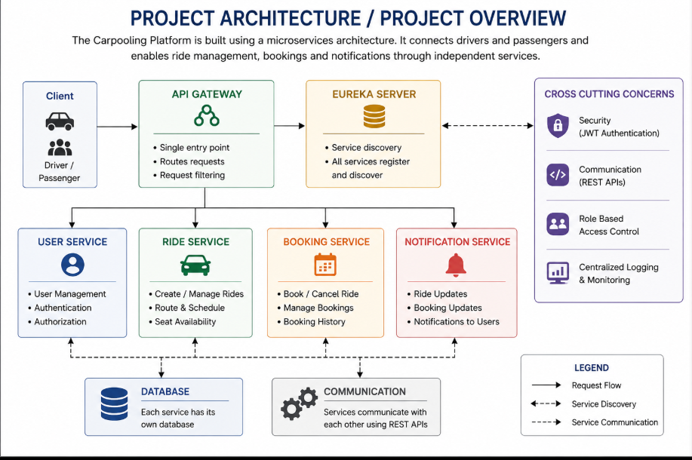
The Carpooling Platform follows a microservices-based architecture developed using Java and Spring Boot. The system provides a centralized platform for drivers and passengers to create, discover, book, and manage rides. The architecture separates the application into independent services, allowing each service to perform a specific business function while making the overall system easier to maintain and scale.
The user interacts with the system through the application interface. Requests are first handled by the Spring Cloud Gateway, which performs API routing and forwards requests to the appropriate microservice. Eureka Server provides service discovery, allowing the individual microservices to locate and communicate with each other efficiently.
The main components of the system are:
- User Service: Manages user information, authentication, and user access.
- Ride Service: Handles ride creation, route details, schedules, and available seats.
- Booking Service: Manages ride bookings, cancellations, and booking-related information.
- Notification Service: Handles ride and booking updates and provides relevant notifications to users.
- API Gateway: Acts as the entry point for client requests and routes requests to the appropriate services.
- Eureka Server: Provides service discovery for communication between the microservices.
- JWT Authentication: Provides secure authentication and role-based authorization for users.
- REST APIs: Enable communication between the application components and microservices.
The architecture provides a modular and scalable solution in which individual services can be developed, maintained, and scaled independently. The combination of Spring Boot, Spring Cloud Gateway, Eureka, JWT, REST APIs, and microservices supports secure ride management, efficient booking, and reliable communication between system components.

